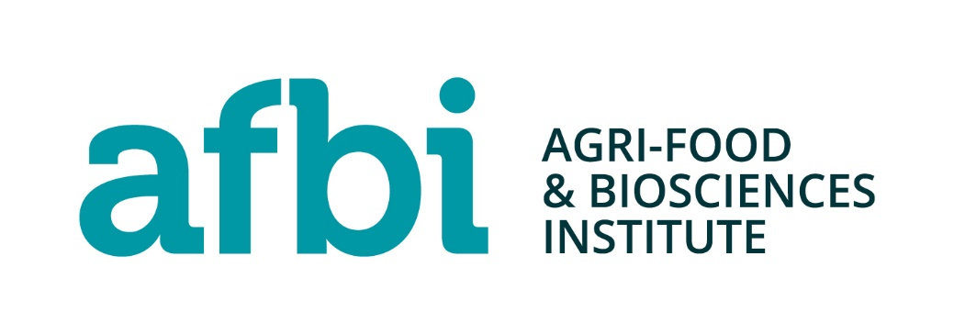

AFBI Consultee List

Organisation:
Action Mental Health
Age NI
Alliance Party of NI
Attention Deficit Disorder NI (ADD-NI)
Autism NI
Belfast Islamic Centre
Bishop/Diocese of Down and Connor
British Deaf Association (NI)
Cara-friend
Carers NI
Children's Law Centre
Chinese Welfare Association (CWA)
Church of Ireland
Committee on the Administration of Justice (CAJ)
Commissioner for Older People NI (COPNI)
Democratic Unionist Party (DUP)
Department for Infrastructure
Department of Agriculture, Environment and Rural Affairs
Department for Communities
Department for the Economy
Department of Education
Department of Finance
Department of Health
Department of Justice
Disability Action
Dyslexia Association of Ireland
Employers' Forum on Disability (EFDNI)
Equality Coalition
Equality Commission for NI
Food Standards Agency (NI)
Gingerbread NI
GMB
Green Party (NI)
Health and Safety Executive for NI (HSENI)
Irish Agriculture and Food Development Authority (TEAGASC)
Leonard Cheshire Disability Livestock & Meat Commission for NI
MENCAP (NI)
Methodist Church in Ireland
Mindwise
Multi-Cultural Resource Centre
National Secular Society (UK)
NI Association for Mental Health (NIAMH)
NI Council for Ethnic Minorities (NICEM)
NI Public Service Alliance (NIPSA)
NI Women's Aid Federation
Orchardville Society
Polish Association NI
Presbyterian Church in Ireland
Rainbow Project
Royal National Institute for the Blind (RNIB)
Royal National Institute for the Deaf - (RNID)
(RSPB) - NI Royal Society for the Protection of Birds
Sinn Féin
Social Democratic Labour Party (SDLP)
The Cedar Foundation
The Executive Office
Ulster Farmer's Union (NI)
Ulster Supported Employment Limited (USEL)
Ulster Unionist Party (UUP)
Women's Forum NI
Women's Resource & Development Agency (WRDA)
Women's Support Network
Young Farmers' Clubs of Ulster (YFCU)

